Atlantic Bluefin Tuna Biological Sampling Update 2010-2015

Walt Golet

University of Maine/Gulf of Maine Research Institute

Hello Everyone,

Over the past few years I have had the pleasure of interacting with many participants in the commercial and recreational bluefin tuna fishery. Most of this time was spent encouraging fishermen to retain samples from bluefin tuna (heads) for our program. Unfortunately, I do not always get the opportunity to share what we do with those samples. Here, I provide a summary of our biological sampling program, including what we are collecting, how we process the samples and what they are telling us. If you should have any questions regarding this work, please feel free to contact me.

It is not surprising that when it comes to bluefin science the U.S. has been and continues to be a leader in cooperative fisheries research. From Frank Mather’s early conventional tagging in the 1960s and 1970s, the aerial surveys and electronic tagging directed by Molly Lutcavage and the most recent biological sampling effort, US fishermen lead the way with cooperative projects. ABTA and all prior organizations which represented US bluefin fisheries have put incredible amounts of time and effort towards supporting collaborative bluefin research. ABTA, its constituents, and the scientific community have long recognized that our understanding of Atlantic bluefin tuna life history is insufficient and continue working to close those gaps in knowledge. Recently, the broader Atlantic community also recognized those research needs and beginning in 2010 ICCAT embarked on the Grande Bluefin Tuna Year Program (GBYP). This initiative aims to improve our understanding of Atlantic bluefin tuna life history (age, growth, reproduction, movement/migration). While Atlantic bluefin tuna have been studied for more than a 100 years, critical gaps in their life history still remain, many of which are important inputs in current stock assessment models.

**Sampling Progress**

In the western Atlantic, scientists have been collecting samples from bluefin tuna for over 50 years. Most of these collections were directed toward a particular life history question as opposed to long-term monitoring. These initial sampling programs were more opportunistic and their objectives were not directed to cover all gears types, months and regions of landings. Why is it important to have broad sampling? Well, restricting your collections to one area, gear type or point in time could bias your interpretation of the stock. How would this work? Let’s say we are interested in knowing the average age of bluefin caught in the Gulf of Maine and we only sample from Cape Cod Bay (historically, a place known to hold very large fish). Those fish may only represent five percent of the total Gulf of Maine landings and if they are all large it skews our perception about the broader Gulf of Maine assemblage. To reduce the influence of any particular variable (month, gear, location) we make our sampling efforts as broad as possible.

Beginning in 2010, US scientists initiated a large scale biological sampling program. The objectives were to collect otoliths, dorsal spines, gonads, muscle tissue and when possible, stomachs. So far we have collected samples for the past six years throughout the Gulf of Maine down into the mid-Atlantic Bight. We have experienced year after year increases in our total sampling efforts an accomplishment linked directly to the participation of the fishery (THANK YOU!). Table (1) provides a summary of our sampling progress to date. Including the 2015 season, we now have one of the, if not the largest sampling database and archive for bluefin tuna by any ICCAT country during this time period. O.K., so we collect a lot of material, the next question is what do we do with it? This is a generic summary, detailed descriptions follow based on the particular research objectives.

|  |  |  |  |  |  |  |  |  |  |
| --- | --- | --- | --- | --- | --- | --- | --- | --- | --- |
| Year | Muscle | Otolith | Spine | Gonad | Males | Females | Avg Round Wt Kg | Avg Len CFL cm | Totals |
| 2010 | 339 | 340 | 213 | 339 | 86 | 61 | 139.6 | 207.9 | 413 |
| 2011 | 282 | 466 | 258 | 207 | 145 | 70 | 139.8 | 202.1 | 538 |
| 2012 | 364 | 554 | 215 | 230 | 158 | 88 | 165 | 203 | 678 |
| 2013 | 340 | 634 | 197 | 259 | 156 | 118 | 172.2 | 209.2 | 741 |
| 2014 | 679 | 677 | 56 | 240 | 132 | 116 | 199 | 219 | 745 |
| 2015 | 986 | 956 | * | * | 146 | 99 | 141 | 219.8 | 956 |
| Totals | 2990 | 3627 | 939 | 1275 | 823 | 552 |  |  |  |

Table 1. Summary statistics for the bluefin tuna biological sampling program. * Indicates samples were not collected and archived. Average round weight and length includes angling category fish and is not indicative of any one category average length or weight. Sample locations included the entire Gulf of Maine (including George’s Bank) and southern New England and the mid-Atlantic Bight.

**Muscle Tissue-**

a) *Energetic Status*-how much lipid (fats) are bluefin acquiring here on the foraging grounds.

b) *Foraging history*- we can use stomach contents and stable isotopes to determine what bluefin have eaten the day they are caught and get estimates for the main contributions of their diet across several months respectively using muscle tissue.

c) *Genetics*- preliminary studies are underway to use genetics to identify “east” and “west” spawners, if this works the genetics may be used to estimate absolute population abundance, similar to work already completed with southern bluefin tuna and recently initiated with pacific bluefin tuna.

d) *Hormone analysis*- identifying the sex of any particular individual bluefin, like many other species, is not possible by simply looking at it. To classify a fish as male or female we need to see the gonads. However, we can now take a piece of muscle tissue and based on the hormones within that tissue classify males and females without the use of the gonads.

**Otoliths-**

a) *Age Estimation*- otoliths can be used to age each fish, telling us what year they were spawned and what the age structure of the population is. It can also give us clues as to what are expectations are for future fishing seasons

b) *Mixing Rates*- Using the chemical signatures in the otoliths we can estimate what percentage of landings are fish that were spawned in the “east” or “west”

**Gonads-**

a) *Sex*- Examining the gonads allows us to determine the numbers of males and females in the landings

b) *Reproductive Status*- Examining the gonads allows us to determine reproductive stage and look for timing of spawning

**Dorsal Spines-**

a) *Age Estimation*-dorsal spines, like otoliths can be used to estimate the age of a fish

**Age Estimation- Otoliths and Dorsal Spines**

So, what’s the big deal about a fish’s age and why do we need to understand it? Age information is fundamental to understanding key attributes of fish populations and as it turns out, those attributes are used in the assessment models to determine stock status (**and your quotas**). Age estimates when combined with length data can be used to determine growth rates. This same information can be used to look at changes in the abundance of different age fish through time to estimate mortality rates. Age estimation and average length (along with gonads, or hormones) at age can be used to establish maturity curves giving us the average length at which 50% of a particular age/length fish is mature. This is the benchmark in fisheries typically used to establish minimum size. Monitoring age each year allows us to see if the population dynamics of fish (in this case bluefin) are changing. Factors influencing changes in the age composition of fish, their average length at age (growth), maturity at age or mortality can be influenced by fishing, environmental factors or both. Age estimation also allows us to identify years with strong year classes and determine what drives those good years.

About a hundred years ago fishery biologists discovered the importance of otoliths. Otoliths are small crystals (bony fish have three sets) which lie in the vestibular (inner ear) system of bony fish. Among other things they help the fish sense its orientation, acceleration, and for some species sound. Otoliths are primary calcium carbonate and grow continuously throughout the life of the fish. Each year the otolith will add two layers (one in summer, one in winter) a translucent one and opaque one. The deposition of the two layers has been confirmed as an annual event which allows us to use them as a marker for one year of life. In order to age the fish the first thing we need to do is extract them. To do this we have to remove the top of the tunas head and clear out all the other stuff (brains). In the photos below you can see this process (Fig 1).

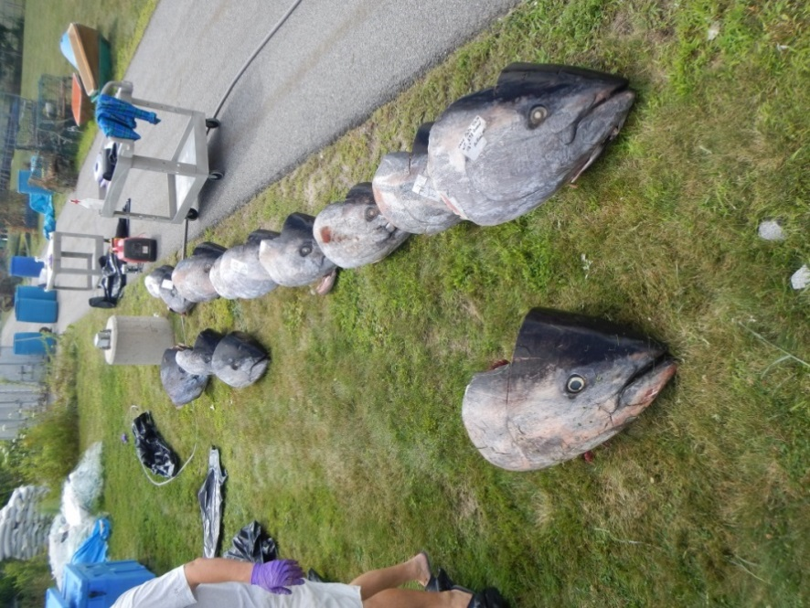 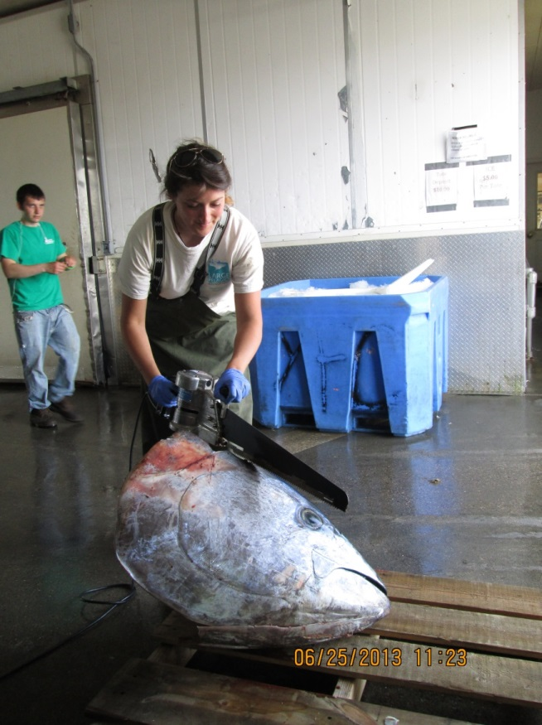

**B**

**A**

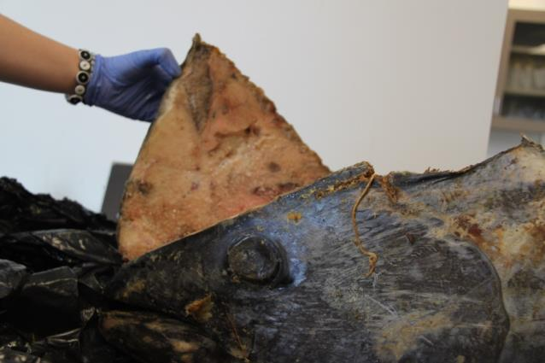 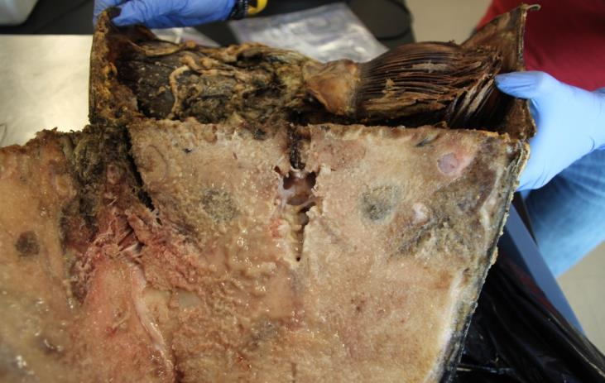

**D**

**C**

Location of otoliths

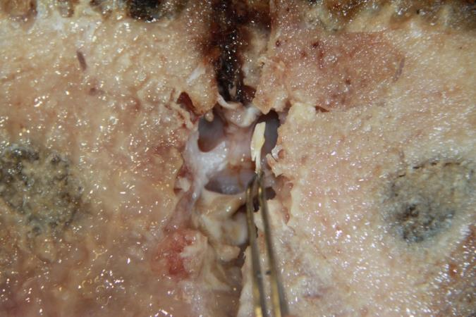 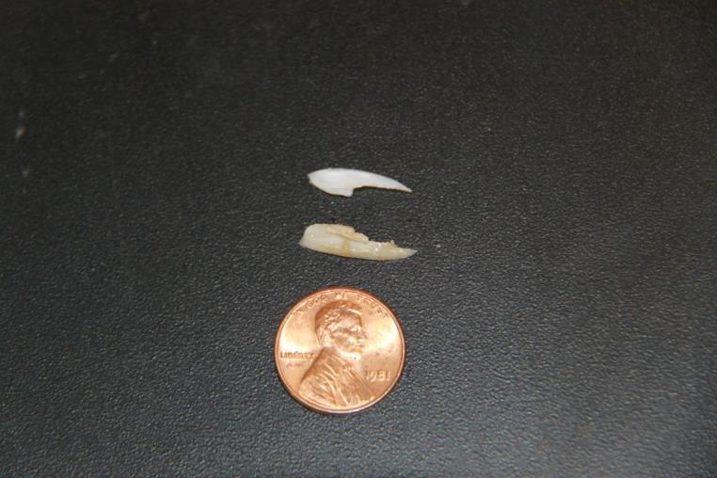

**F**

**E**

 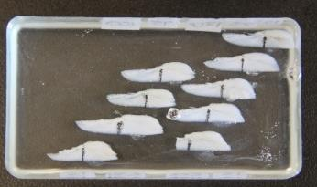

**H**

**G**

Fig 1. A&B-bluefin heads are spread out for processing and the placement of each cut is assessed. C- the top of the head is removed about ½ inch above the eye. D- Biological material (brains, glands) are removed to expose the location of the otoliths. E- Otoliths are carefully removed from the skull, cleaned and stored for processing. F- Size of sagittal otoliths from a 74 inch fish. G- Magnified view of the whole sagittal otoliths from a bluefin tuna. H- Otoliths that have been mounted in epoxy for sectioning.

Once the otoliths have been removed, they are cleaned, weighed and dried. The rings used to estimate the age of the fish are not visible on the outside of the otolith. To expose the rings, each otolith is mounted in epoxy resin (this keeps the otoliths from cracking when we section them, they are very brittle), and cut with a low speed diamond saw (Fig 2.).

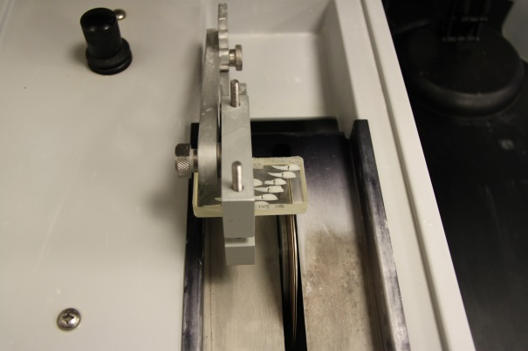

Fig 2. Otoliths being sectioned with a low speed diamond saw.

Once the otoliths have been sectioned they are polished with a fine grain paper to expose the rings and then magnified under a dissecting scope. Each image is photgraphed and enhanced to maximize the contrast of the rings (Fig 3.).

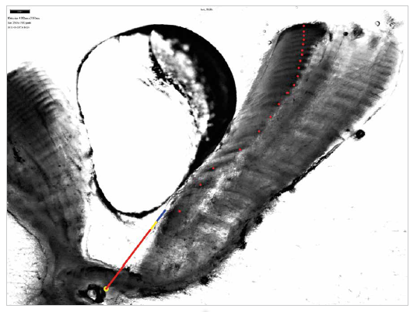

Fig 3. Sectioned photo of a sagittal otolith from a 104 inch curved fork length bluefin caught in Ipswich Bay August of 2010. Notice the alternating dark and light bands, each set of bands (one light, one dark) represents one year of life. We only count one of the bands, otherwise we would be doubling the age of the fish. Each red dot is one year of life for a total of 19 years.

Dorsal spines (the first large spine from the first dorsal fin) can be used to age fish too as they also deposit rings (Fig 4.). However, spines are bone and that bone is metabolically active which means there is blood flowing in the center of the spine. As the fish continues to grow so too does the spine. As the inside of the spine grows it removes the rings from the first years of life. Therefore, spines are best used for estimating the age of fish younger than ten and ideally for fish age 0-4. Over the past few years we have seen a greater percentage of older fish in the landings, particularly for the general category and the otolits have been better structures for aging.

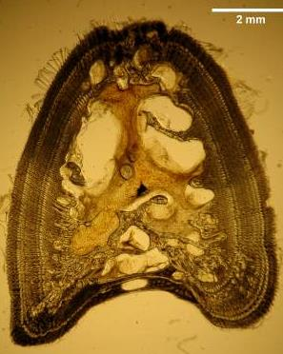

Fig 4. A cross section of a dorsal spine from a bluefin tuna. Like the otolith, the spine also shows annual rings, but the middle of the spine is metabolically active (see all the spaces) and as the spine grows the rings from the first year of life disappear.

**Estimating Natal Origin (Stock Mixing)**

As most of you are aware, bluefin are currently managed as two stocks, an east and west divided by the 45°W meridian. We have known for decades that fish cross this line as young as one year old, but we have not been able to determine the extent of mixing and if it’s influenced by environmental conditions, the size of either stock or some other variable/s. The development of electronic archival tags has provided unprecedented insights into bluefin and other large pelagic fish migrations. However, due to costs, deploying hundreds or thousands of tags each year is not feasible so electronic tagging is one piece of the puzzle. Therefore, we try to use multiple methods with which to identify the mixing of the two stocks. Otoliths are another way we can assess the mixing rates for the bluefin stock. Water properties of the world’s oceans are not the same in every location. Due to environmental conditions, different regions have different concentrations of certain elements and if those are accumulated in the tissues of fish we can use them as a natural tag to determine where the fish was spawned. This is true for Atlantic bluefin tuna that are known to have spawning grounds in the eastern and western Atlantic which express very different water properties. Dr. Dave Secor at the University of Maryland developed techniques to use the differences in oxygen isotopes between the spawning grounds as a marker for estimating mixing rates (Fig 5.). The two regions have different oxygen 18 isotopic values and when the bluefin is spawned, that signature is captured in the otolith. Since the otolith is a metabolically inert tissue whatever is captured within it not only stays there unaltered, but also acts as a time recorder. Hence we know exactly what part of the otolith represents the first year of life and we can analyze only that portion.



Fig 5. Differences in the mean O18 values between the east and west spawning grounds. These values are captured in the otoliths of the fish which are spawned in each region and can be used to separate or classify bulk mixing rates. Taken from Secor et al 2011. Coll. Vol. Sci. Pap. ICCAT, 68(1):212-222.

Similar to the methods used for aging, each otolith is sectioned after being embedded in epoxy. A thicker section is cut and the sample is placed on a micromill (think of a really small dentist drill attached to a microscope). The machine is programmed to drill out the core of the otolith. We only want the core of the otolith otherwise we will begin to incorporate material that has been laid down outside the first year of life. To do this a general pattern of the core is overlaid on each sample (Fig 6.). The pattern is adjusted for each individual otolith and the drill makes several passes over the otolith to remove material. This material is sent out and analyzed and when returned has a value unique to each fish. Through a series of mathematical analyses we can begin to classify the fish and estimate a bulk mixing rate for that sample. For example, if we have 150 otoliths we can say that 60% are west and 40% are east. Mathematical routines have been developed to estimate probability of natal origin for each individual fish, but we have just begun using this method.



Fig 6. A sectioned otolith showing the area of milling (solid light blue area). Material from the first year of life is milled out and compared with reference material from a spawning ground in the east and west Atlantic.

**Sex Ratios**

Back in the 1970’s Canadian scientists began to examine the gonads of bluefin landed in the Maritime Provinces and record the number of males and females in the catch. From this work came two interesting findings, first males appeared to be more prevalent and second, they also appeared to grow a little faster and reach a larger size than females. These researchers also indicated that males weigh more than females for a given fork length (and age). In some regions and during some years, landings of bluefin tuna in Canada contained twice as many males as females. After a series of papers published at ICCAT in the late 1970s and early 1980s on this topic, there has been little information on the sex ratios of bluefin or the differences in growth between males and females. In the Gulf of Maine, to my knowledge, there have been no published studies looking the sex ratios or sex specific growth patterns of bluefin. Over the past few years we have been collecting data on the numbers of males and females in the catch using either visual identification of the gonads, or through a new hormone assay we developed. The preliminary results (Table 1) support the initial Canadian studies. In the Gulf of Maine, in certain years males outnumber females 2:1. We are currently evaluating the growth patterns of males and females, but our initial findings are in line with historical records (e.g., males grow bigger than females).

**Education and Outreach**

Every year I do as much outreach as possible for students in my classes at UMaine, the general public and children grades K-12 (Fig 7). We do this at tournaments, at the Gulf of Maine Research Institutes Lab Venture Program and for a number of other academic and non-profit organizations along the east coast. Our focus is on educating people about the bluefin fishery, the cooperative research projects we conduct and the how, where, when, what we do with the samples. Often times I get the opportunity to allow some of the grade school students to help me extract the otoliths and do some general exploring in as they call it… “the yucky stuff.” It’s pretty amazing to see peoples/students reaction to a head from a 900 pound bluefin and to give people exposure to something they would normally never see in their lifetime.

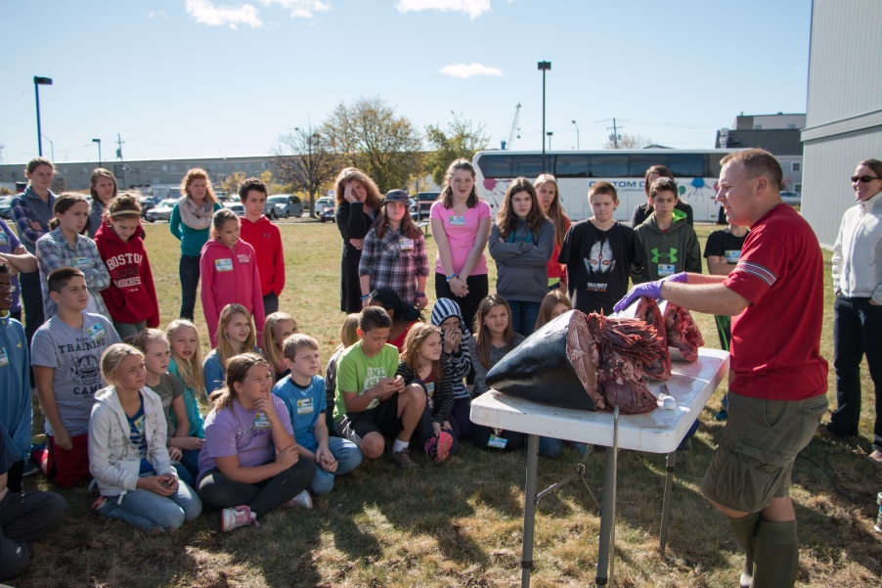

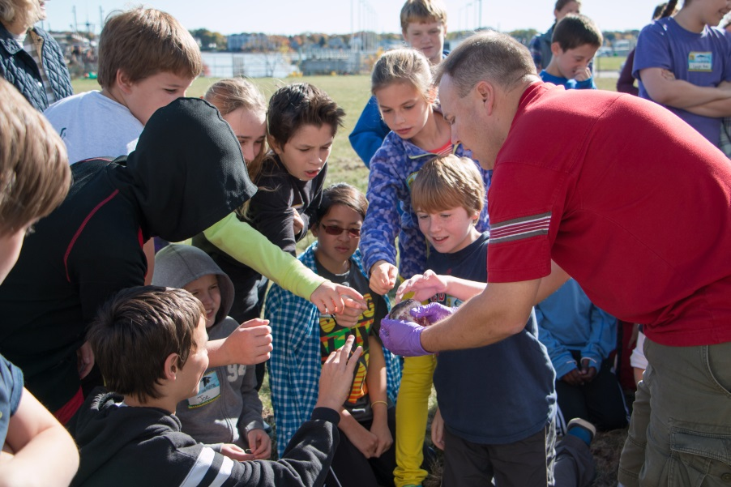

Fig 7. Demonstration for the LabVenture Program at the Gulf of Maine Research Institute. Students get the chance to help extract out the tissues we use for our research and do some general exploring of the samples. In the bottom photo students are examining the eye of the tuna.

**Oddities**

Each year we hear stories or see pictures of weird things that people observe in the bluefin fishery. This year I am including some photos of a fish which the crew at Nantucket fish set aside for us. The head of this fish does indeed look weird and I have joked with people it is the first evidence of a cross between a bluefin and dolphin. WHICH BY THE WAY I AM KIDDING ABOUT! Check out the photos below. Thanks to the guys at Nantucket fish for saving this. Also, take a look at the coconut that was removed from another bluefin’s stomach!

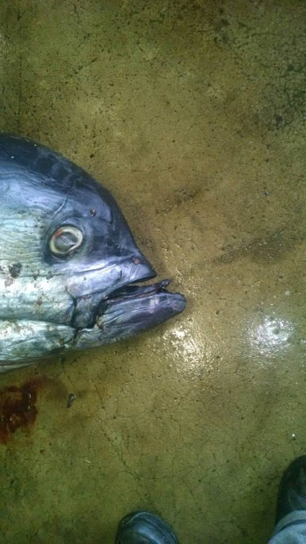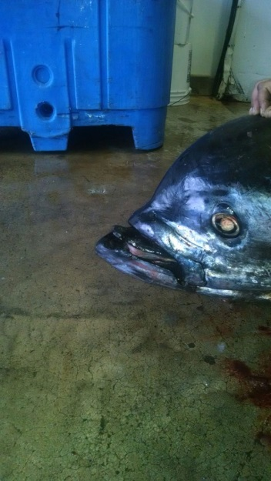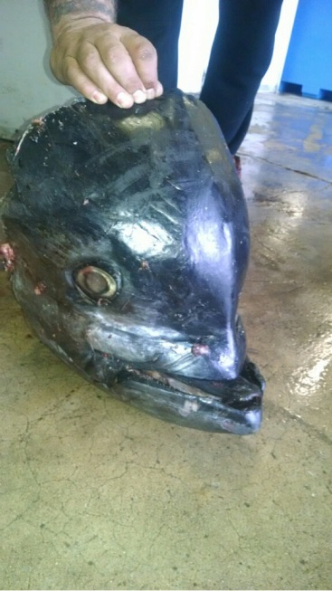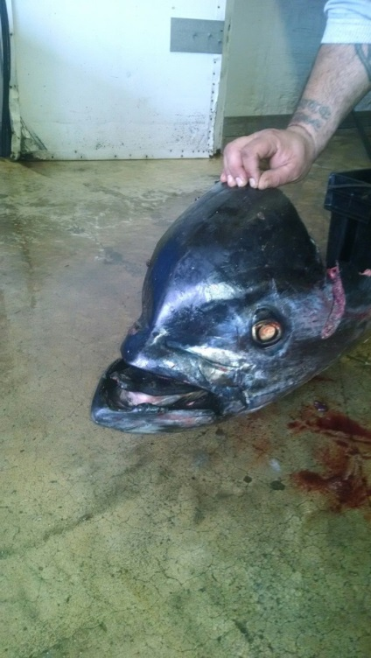

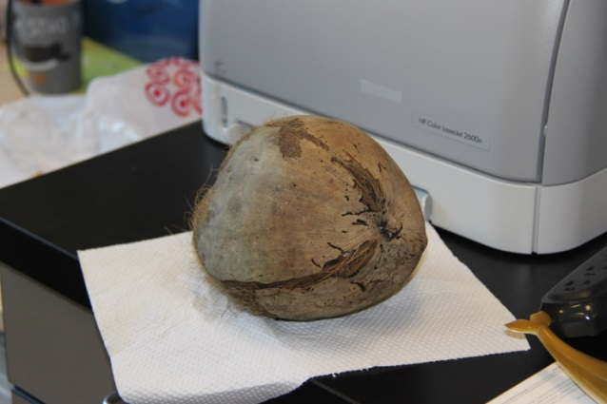

**2016**

We will continue to collect biological samples again this year. If you are not participating and would like to its easy. Simply save your tuna heads. We realize this can be a pain when you are cleaning at sea, but any effort is appreciated and the samples are extremely valuable. We never know which sample will yield the next interesting discovery (Fig 8). We collect most of them from the dealers, but can on occasion collect them from individual vessels. We thank you for your past participation and look forward to continued success of this program. Thanks to everyone who has helped us along the way and good luck this coming season. More updates with specific findings will follow.

walter.golet@maine.edu

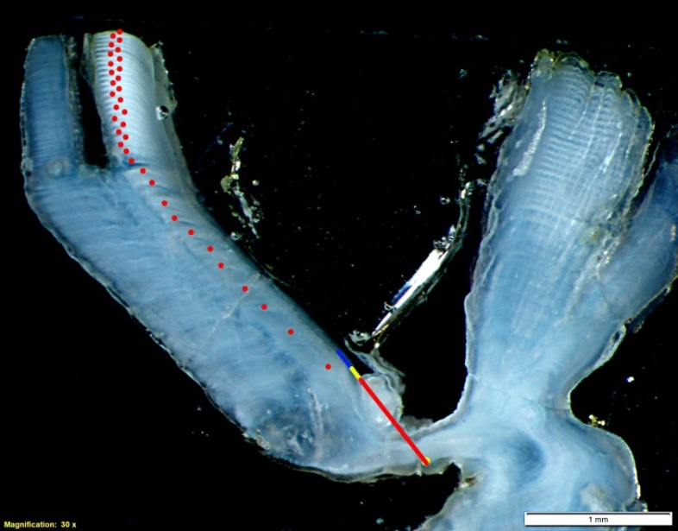

Fig 8 Picture of a sectioned bluefin tuna otolith collected by our colleagues at the Department of Fisheries and Oceans, Canada. This fish was 115 inches long and 35 years old! This is exceptionally old for a fish of this length. It was sampled in the Gulf of St. Lawrence fishery and may be one of the oldest tunas ever directly aged!